

KING KHALID UNIVERSITY
COLLEGE OF COMPUTER SCIENCE

Elderly Assistant Healthcare System

By :

Farah Saleh Saeed (442807545)
Danah Ahmad Alkbibi (442807555)
Norah Mohammed AlFertish (442807539)
Shahad Saeed Alsareei (442809567)

Supervised By :

Dr. Abdullah Alqahtani

This Project Documentation is the lecture on computer science the requirement for the Degree of B.Sc. in Computer Science.

2023/ 1445

ABSTRACT

A chronic disease is a condition or disease that is permanent or long-lasting in its effects, or a disease that comes with time and progresses slowly. This disease often lasts for three months or more.
This application has been proposed, which is a monitoring system for monitoring chronic diseases in the elderly, such as diabetes, high blood pressure, asthma, and gait disorders. The application aims to connect the patient with a specialist doctor when necessary, provide the necessary instructions, and track patients’ conditions by the doctor through calls and messages, as most The elderly suffer from chronic diseases, and some of them live in remote areas, which makes it difficult for them to reach hospitals and care centers, and many complications may occur to them if there is no follow-up.

TABLE OF CONTENTS

ABSTRACT 2
ACKNOWLEDGEMENTS 7
CHAPTER 1: INTRODUCTION 8
1.1 Introduction 9
1.2 Motivations 9
1.3 The Aim of The Project 10
1.4 Project Scope 10
1.5 Objectives 10
1.6 Problem Definitions 11
1.7 Proposed Solutions 11
1.8 Limitation 12
1.9 Project Plan 12
CHAPTER 2: LITERATURE REVIEW 13
2.1 Overview 14
2.2 Similar Systems 14
2.2.1 Teladoc Health Application 14
2.2.2 MyChart Application 15
2.2.3 HealthTap Application 16
2.7 Comparative Study 18
CHAPTER 3: ANALYSIS 19
3.1 Methodologies 20
3.2 System Requirements 22
3.2.1 Hardware Requirements 22
3.2.2 Software Requirements 22
3.3 Functional requirements 23
3.3.1 Functional Requirements for Patient: 23
3.3.2 Functional Requirements for Doctor: 24
3.3.3 Functional Requirements for Admin: 24
3.4 Non-functional requirements 24
3.5 Use Case Diagram 25
3.6 Activity Diagram 27
3.6.1 Activity Diagram for Patient 27
3.6.2 Activity Diagram for Doctor 28
3.6.3 Activity Diagram for Admin 29
3.7 Sequence Diagram 30
3.7.1 Sequence Diagram for Sign-Up 30
3.7.2 Sequence Diagram for Login 31
3.7.3 Sequence Diagram for Search for Doctor 32
3.8 Class Diagram 33
3.9 Data Flow Diagram 34
3.9.1 Context Diagram 34
3.10 ERD Diagram 35
REFERENCES 36

LIST OF FIGURES
Figure 2. 1: Teladoc Health 14
Figure 2. 2: MyChart ApplicationFigure 2. 1: Teladoc Health 14
Figure 2. 2: MyChart Application 15
Figure 2. 3: HealthTap ApplicationFigure 2. 2: MyChart Application 15
Figure 2. 3: HealthTap Application 16
Figure 3. 1: Agile Methodology 20
Figure 3. 2: Use Case Diagram 26
Figure 3. 3: Activity Diagram for Patient 27
Figure 3. 4: Activity Diagram for Doctor 28
Figure 3. 5: Activity Diagram for Admin 29
Figure 3. 6: Sequence Diagram for Sign-Up 30
Figure 3. 7: Sequence Diagram for Login 31
Figure 3. 8: Sequence Diagram for Search for Doctor 32
Figure 3. 9: Class Diagram 33
Figure 3. 10: Context Diagram 34
Figure 3. 11: ERD Diagram 35

LIST OF TABLES

Table 1. 1: Project Plan 12
Table 2. 1: Comparative Study 18
Table 3. 1: Hardware Requirements 22
Table 3. 2: Software Requirements 22

ACKNOWLEDGEMENTS

We begin by expressing our gratitude to the Almighty for blessing us with success in our endeavors. We extend our heartfelt thanks to our esteemed Supervisor and the supportive staff of the Department of Information Systems. This is also an opportune moment for us to convey our profound appreciation and utmost respect to Dr. Abdullah Alqahtani for his exemplary guidance, continuous monitoring, unwavering encouragement, and the invaluable assistance and counsel he provided throughout this journey.

CHAPTER 1: INTRODUCTION

1.1 Introduction
A significant portion of the elderly population grapples with chronic ailments, including high blood pressure, diabetes, cardiovascular issues, and gait disorders. These conditions demand ongoing monitoring and specialized healthcare, underlining the crucial need for comprehensive care and the adoption of a healthy lifestyle, encompassing a balanced diet and suitable physical activities. Therefore, our envisioned system is designed with a keen focus on catering to this specific demographic.
The primary objective of this system is to streamline communication between elderly patients and healthcare professionals specializing in their respective conditions. Beyond this fundamental function, it offers a spectrum of additional services to enhance their well-being. These encompass reminders for medication schedules, tailored advice to support their health conditions, such as hydration reminders, and gentle nudges for regular walks. The overarching aim is to empower elderly individuals with chronic diseases to better manage their health, maintain their independence, and experience an improved quality of life.

1.2 Motivations
The motivation for creating this system is due to what the elderly suffer from going to the hospital, transportation problems, or the lack of hospitals close to their homes. Therefore, this system works to facilitate periodic follow-up of the elderly to protect their health from any complications in an easy, inexpensive, and effective way. And limit the sudden decline in their health level.

1.3 The Aim of The Project
The core purpose of this system is to simplify the health monitoring of elderly individuals dealing with prevalent chronic conditions like heart disease and diabetes. It achieves this by streamlining the communication between patients and healthcare providers, swiftly responding to emergencies, and delivering timely medication reminders and health advice. This proactive approach aims to prevent complications that often arise in such cases.

1.4 Project Scope
This application is designed for the monitoring of senior citizens aged 70 and above who are managing chronic health conditions. To utilize this application, users must register through their national identification card, and internet connectivity is essential for its functionality. Initially, the system will be implemented within the Asir region, with the aspiration that it will achieve success and eventually expand for use throughout all regions of the Kingdom.

1.5 Objectives
The objectives of this project, which is the development of a monitoring system for chronic diseases in the elderly, encompass the following key goals:
- To improve access to healthcare services for elderly individuals, particularly those residing in remote areas, who may face challenges in reaching hospitals or care centers due to their chronic conditions.
- To enable effective management of common chronic diseases such as diabetes, high blood pressure, asthma, and gait disorders among the elderly population.
- To facilitate seamless communication between elderly patients and specialist doctors, ensuring that they can easily connect with healthcare professionals when necessary.
- To provide timely and tailored medical instructions to patients, helping them manage their conditions more effectively and avoid complications.
- To enable doctors to remotely monitor the health conditions of elderly patients through calls and messages, allowing for continuous assessment and adjustment of treatment plans.
- To enhance the overall quality of life for elderly patients by empowering them to maintain their independence and well-being through effective disease management.
- To reduce healthcare costs by minimizing emergency visits and hospitalizations through proactive remote monitoring and intervention.

1.6 Problem Definitions
In the realm of chronic and electronic diseases, certain models of care necessitate swift guidance during moments of need and continuous daily monitoring. Many individuals grappling with these conditions find themselves without immediate assistance, leading to a sense of isolation and vulnerability. Factors like weakened physical strength, limited mobility, and difficulty in self-care further compound the challenges they face. Additionally, issues related to memory and recollection can pose significant obstacles, making it imperative to provide a supportive and responsive healthcare system that caters to these unique needs.

1.7 Proposed Solutions
The selection of this application is driven by the imperative to bridge the communication gap between patients and doctors, primarily because of the patient's limited ability to physically visit hospitals and healthcare centers. Key features of the application include:
- Continuous Condition Monitoring: The application ensures the ongoing monitoring of patients' health conditions through regular readings and specialist doctor follow-ups.
- Medication Appointment Alarms: It provides timely reminders for medication appointments to help patients adhere to their treatment plans.
- Information Provision: The application offers valuable information related to the patient's health condition and management.
- User Training: It includes a user-friendly training course to guide individuals in using the application effectively, ensuring they can make the most of its features.
- Simplified Data Entry: The application streamlines the process of entering information through the use of large, clear buttons, making it accessible for users with various levels of technological proficiency.
- Text Size Customization: Users have the option to enlarge text within the application to cater to individual preferences and needs.
By encompassing these functionalities, the application aims to facilitate remote healthcare access and empower patients to manage their health effectively, even when unable to physically visit healthcare facilities.

1.8 Limitation
The system exhibits certain limitations, which include its dependency on an internet connection; it may not function in the absence of internet access. Additionally, it may face challenges in areas with a weak network infrastructure. Furthermore, the system is designed to address a specific set of chronic diseases, namely heart conditions, diabetes, hypertension, asthma/respiratory ailments, and gait disorders, limiting its scope to these health conditions.

1.9 Project Plan
Task / Week | W1 | W2 | W3 | W4 | W5 | W6 | W7 | W8 | W9 | W10 | W11 | W12 | W13 | W14 | W15
Choosing subject for project
introduction
Compartive studies
Analysis
Designing
Conclusion and future studies
Prepare for the final discussion

Table 1. 1: Project Plan

CHAPTER 2: LITERATURE REVIEW

2.1 Overview
In the preceding chapter, we delved into the problem statement, project impact, and the scope of our project. We thoroughly examined the aims and objectives guiding our project. In this chapter, we shift our focus to conducting a comprehensive literature review. This review is aimed at comparing, analyzing, exploring, and gaining a deeper understanding of prior research efforts in this field. It serves the purpose of identifying existing knowledge and pinpointing research gaps that our project can address.

2.2 Similar Systems
In this section, we will discuss similar systems.

2.2.1 Teladoc Health Application
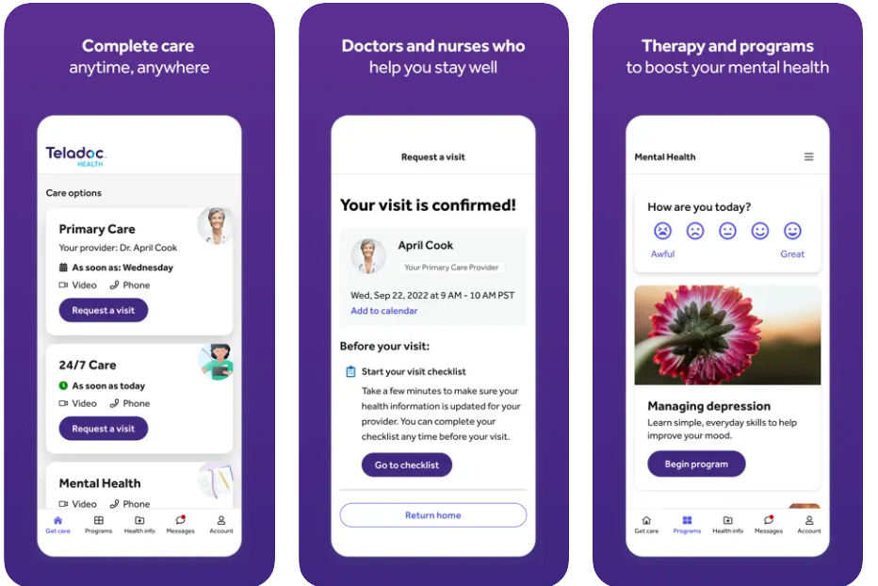
Teladoc Health is a prominent telehealth company that provides virtual healthcare services, including medical consultations, via video or phone calls. It offers 24/7 access to a network of board-certified doctors, specialists, and therapists for a wide range of medical conditions. Teladoc Health's platform is designed to connect patients with healthcare providers remotely, allowing them to seek medical advice, get diagnoses, and receive treatment recommendations from the comfort of their own homes.
Figure 2. 1: Teladoc Health

Figure 2. 2: MyChart ApplicationFigure 2. 3: Teladoc Health
Advantages of "Teladoc Health":
- Offers 24/7 access to board-certified doctors via video or phone calls.
- Provides a wide range of medical services beyond chronic disease management.
- Convenient and user-friendly interface.
Disadvantages of "Teladoc Health":
- Requires a subscription or insurance coverage, making it less accessible for some users.
- The application doesn't provide a chat for the patient to communicate with the doctor
- It doesn't provide timely reminders for medication appointments to help patients adhere to their treatment plans.
- Users don't have the option to enlarge text within the application to cater to individual preferences and needs.

2.2.2 MyChart Application
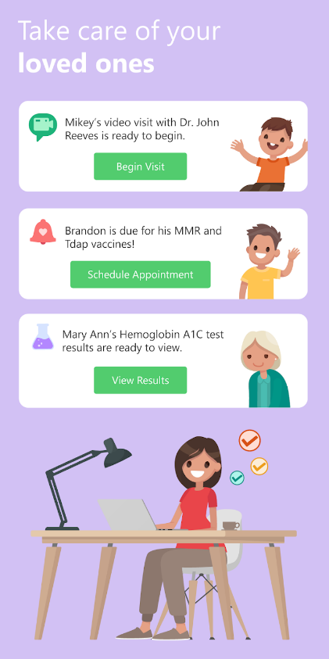
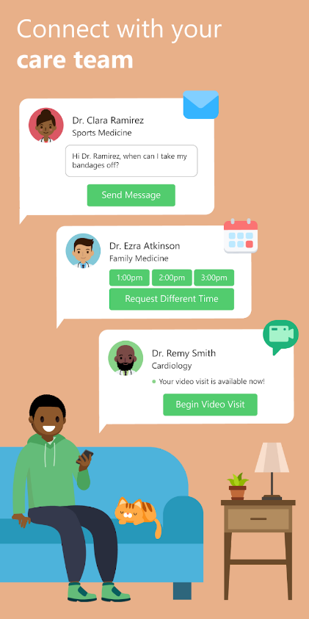
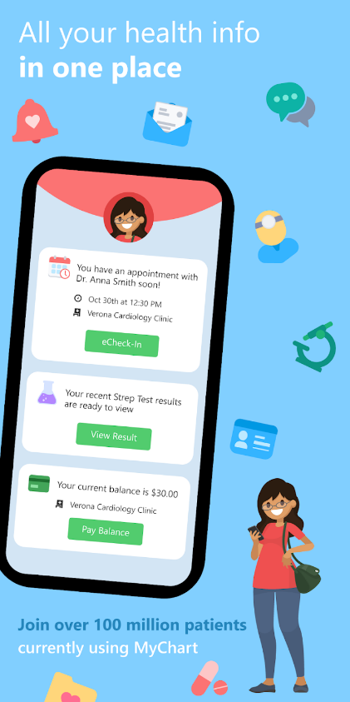
MyChart is a patient portal and mobile application developed by Epic Systems, a leading electronic health record (EHR) software company. MyChart is designed to facilitate communication and engagement between patients and their healthcare providers. It offers a range of features that empower patients to manage their healthcare more effectively.
Figure 2. 4: MyChart Application

Figure 2. 5: HealthTap ApplicationFigure 2. 6: MyChart Application

Advantages of " MyChart ":
- Integrates with various healthcare providers and electronic health records (EHR) systems.
- Allows patients to schedule appointments, view lab results, and communicate with their healthcare team.
- It provides timely reminders for medication appointments to help patients adhere to their treatment plans.
- The application provides a chat for the patient to communicate with the doctor
Disadvantages of " MyChart ":
- It is not a user-friendly interface.
- Focuses more on general healthcare management and does not provide specialized chronic disease monitoring.
- Users don't have the option to enlarge text within the application to cater to individual preferences and needs.

2.2.3 HealthTap Application

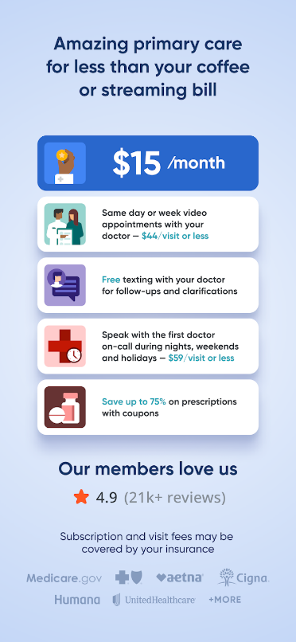
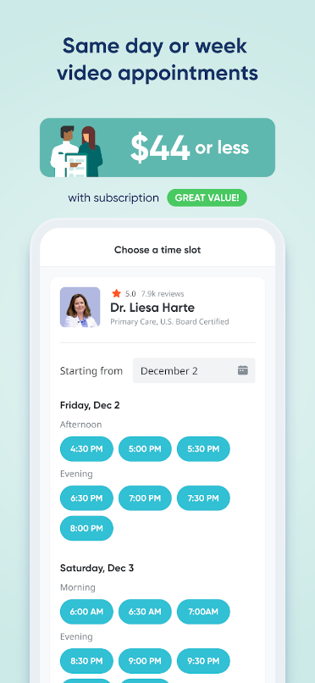
HealthTap is a mobile application and online platform that provides access to virtual healthcare services and medical information. It is designed to offer users a range of medical resources, including telemedicine consultations, symptom checkers, health information, and guidance from healthcare professionals
Figure 2. 7: HealthTap Application
Advantages of “ HealthTap ":
- user-friendly interface
- It Provides video calling with doctors, specialists, and therapists.
- It provides specialized chronic disease monitoring.
- The application offers valuable information related to the patient's health condition and management.
Disadvantages of " HealthTap ":
- Costs apply for services.
- The application doesn't provide a chat for the patient to communicate with the doctor
- Users don't have the option to enlarge text within the application to cater to individual preferences and needs.
- It doesn't provide timely reminders for medication appointments to help patients adhere to their treatment plans.

2.7 Comparative Study
This section shows a comparison based on the similar functional requirements used in the applications. Table 2.1 illustrates the comparisons based on 8 features on 3 apps.
Table 2. 1: Comparative Study
 | Proposed Application | Teladoc Health | MyChart | HealthTap
User-friendly interface | YES | YES | NO | YES
The application provides a chat for the patient to communicate with the doctor | YES | NO | YES | NO
It provides specialized chronic disease monitoring. | YES | YES | NO | YES
It provides timely reminders for medication appointments to help patients adhere to their treatment plans. | YES | NO | YES | NO
The application offers valuable information related to the patient's health condition and management. | YES | YES | YES | NO
The application simplifies data input with user-friendly, large, and clear buttons. | YES | NO | NO | NO
Users have the option to enlarge text within the application to cater to individual preferences and needs. | YES | NO | NO | NO
Free cost | YES | YES | YES | NO

CHAPTER 3: ANALYSIS

3.1 Methodologies
Each project in software development needs to follow an approach for structuring and organizing the processes and tasks that the team can deal with. This project follows an agile methodology for managing and organizing the process of development in the understanding, gathering requirements, analyzing requirements, designing requirements, implementing, and testing of the project. The use of agile methodology helps to provide an easy understanding and interpretation of its separate phases, which enables it to correctly identify the requirements at each stage and make appropriate project planning as shown in Figure 3.1. In addition to the ease of handling changes in project requirements.
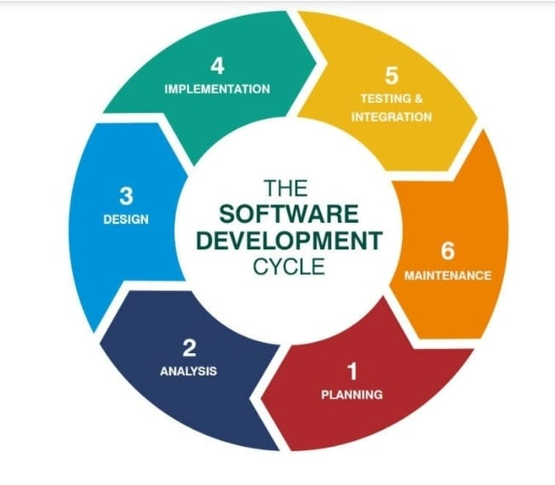
Figure 3. 1: Agile Methodology

The software development process typically adheres to the Agile model, which consists of distinct, sequential phases to ensure the successful creation and ongoing maintenance of an application. These phases are as follows:

- Requirements Analysis:
- Requirements Definition: In this phase, the project team thoroughly defines and documents all project requirements, including who the end-users are, what data must be entered, how the application will be used, and what information it should provide to users.
- Validation and Feasibility Assessment: The gathered requirements are rigorously assessed for their validity and feasibility, ensuring that they can be effectively incorporated into the application.
- System Design:
- Architectural Design: Based on the defined requirements, the project team creates a comprehensive architectural plan for the application.
- Database and User Interface Design: Database structures and user interfaces are meticulously planned and designed.
- Modeling: Diagrams and models are generated to visually represent the application's structure and functionality.
- Implementation :
- Development: Developers proceed to write the actual code, implementing the methods and algorithms necessary to bring the application to life.
- Testing:
- Unit Testing: Each component is tested individually to ensure they function correctly.
- Integration Testing: The different components are integrated and tested to guarantee they work together seamlessly.
- System Testing: The complete system is rigorously tested to ensure it aligns with the established requirements.
- Deployment:
- Release: Upon successful testing and verification, the application is prepared for deployment and made available to users.
- Bug Fixes: Any identified bugs or issues are addressed and resolved before the final deployment.
- Maintenance:
- Ongoing Support: Following deployment, a maintenance process is in place to provide continuous support, address user-reported issues, apply updates, and ensure the application's ongoing smooth operation.

3.2 System Requirements
In this section, we will discuss hardware and software requirements.

3.2.1 Hardware Requirements
Table (3.1) shows the system's hardware requirements.
Table 3. 1: Hardware Requirements
Hardware | Specifications
Computer | Processor: Core i5 or higher.  RAM: 8 GB.  Hard Disk 256 GB
Mobile Device | Android  IOS

3.2.2 Software Requirements
Software tools used in our proposed system as depicted in Table 3.2
Table 3. 2: Software Requirements
Tool / Language | Reason for Using This Program
Dart | Dart: is a client-optimized language for developing fast apps on any platform. Its goal is to offer the most productive programming language for multi-platform development, paired with a flexible execution runtime platform for app frameworks [4].
Android Studio | Android Studio: is the official Integrated Development Environment (IDE) for Android app development, based on IntelliJ IDEA. On top of IntelliJ's powerful code editor and developer tools [5].
XML | XML: is one of the most widely used formats for sharing structured information today: between programs, between people, between computers and people, both locally and across networks [6].
The Firebase | The Firebase Realtime Database is a cloud-hosted NoSQL database that lets you store and sync data between your users in real-time. NEW: Cloud Firestore enables you to store, sync, and query app data at a global scale [7].

3.3 Functional requirements
Functional requirements, often referred to as "functionality requirements," are a key part of software and system requirements engineering. They describe the specific functions, features, and capabilities that a software application or system must possess to meet the needs of its users and stakeholders. Functional requirements provide a detailed description of how the system should behave under various conditions and interactions.

3.3.1 Functional Requirements for Patient:
- The patient should be able to register
- The patient should be able to log in
- The patient should be able to update the information
- The patient should be able to log out
- The patient should be able to search for doctors by specialist
- The patient should be able to set an appointment with the doctor
- The patient should be able to chat with doctors
- The patient should be able to receive medical instruction
- The patient should be able to update health records

3.3.2 Functional Requirements for Doctor:
- The doctor should be able to register
- The doctor should be able to log in
- The doctor should be able to update the information
- The doctor should be able to log out
- The doctor should be able to view the patient's requests
- The doctor should be able to accept or reject patient requests
- The doctor should be able to chat with patients
- The doctor should be able to give instructions to patients
- The doctor should be able to update health records for patients

3.3.3 Functional Requirements for Admin:
- The admin should be able to log in
- The admin should be able to update the information
- The admin should be able to log out
- The admin should be able to manage the registration of doctors
- The admin should be able to manage patients
- The admin should be able to manage doctors
- The admin should be able to view statistics about patients and doctors

3.4 Non-functional requirements
In addition to the functional requirements, non-functional requirements are equally critical to ensuring the system's success. These non-functional requirements encompass various characteristics and features that must be integrated into the system:
- Usability: The user interface must be intuitive, with clearly defined navigation paths and explanatory texts for each system function. Users should not encounter ambiguity when using the application.
- Efficiency: The system must operate efficiently, delivering smooth performance even during peak usage periods. It should accommodate a large number of users and companies without compromising its responsiveness.
- Security: Data within the system must be afforded a high degree of protection against unauthorized access or loss. Robust security measures should be in place to safeguard sensitive information.
- Reliability: The system must ensure continuous and reliable operation. It should incorporate mechanisms to prevent the entry of incorrect data and maintain data integrity.
- Scalability: The system should be designed to easily scale to accommodate future growth in users and data volume.
- Performance: The system should exhibit high performance, with rapid response times and minimal downtime.

3.5 Use Case Diagram
A use case diagram is a visual representation, typically created using the Unified Modeling Language (UML), that illustrates how a system engages with external actors. These actors can include users, other systems, or entities. Use case diagrams are a widely used tool in software development and systems engineering, employed to encapsulate and explain a system's functional requirements. They achieve this by visually outlining the different methods by which users or external entities can interact with the system.
Figure 3.2 will provide a use case and a detailed description of all the functions in the system. Some functions are common between the users of the system (admin, patient, and doctor) and some functions are specific for each user.
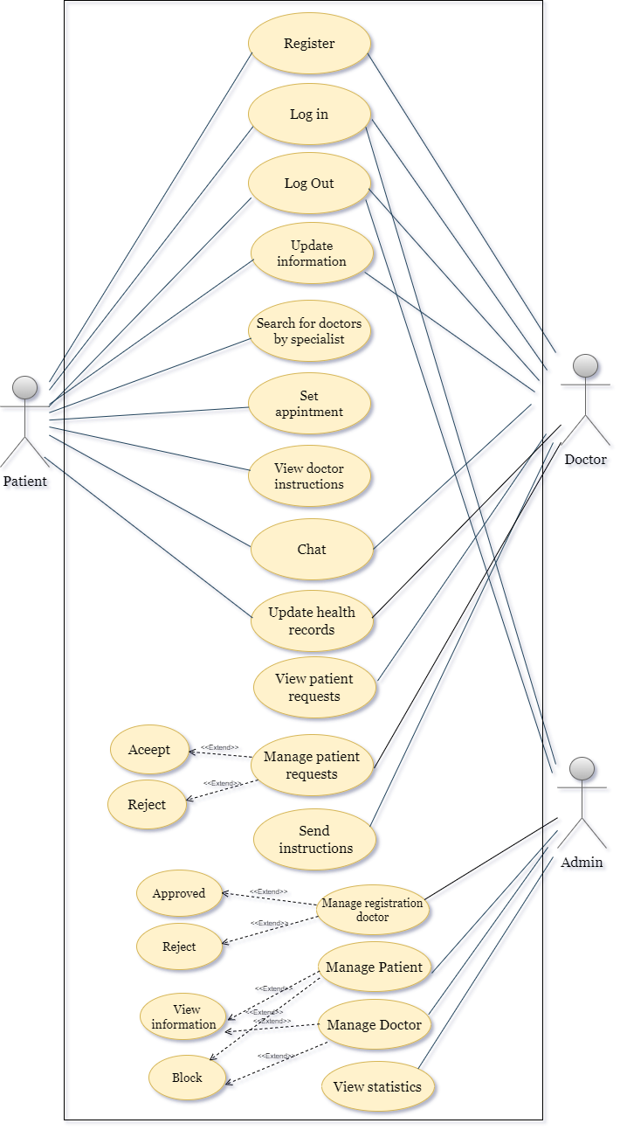
Figure 3. 2: Use Case Diagram

3.6 Activity Diagram
An activity diagram is a type of UML (Unified Modeling Language) diagram that is used to visually represent the workflow or the sequence of activities and actions within a system, process, or software application. It is a graphical representation that helps in modeling the dynamic aspects of a system or process, akin to what is represented in Figures 3.3 to 3.5.

3.6.1 Activity Diagram for Patient

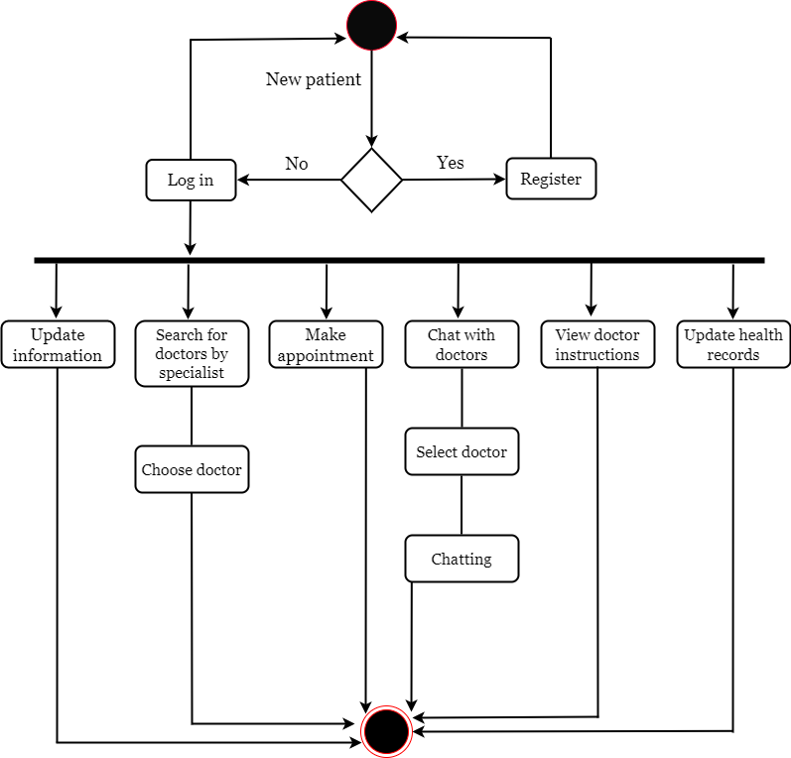
Figure 3. 3: Activity Diagram for Patient

3.6.2 Activity Diagram for Doctor

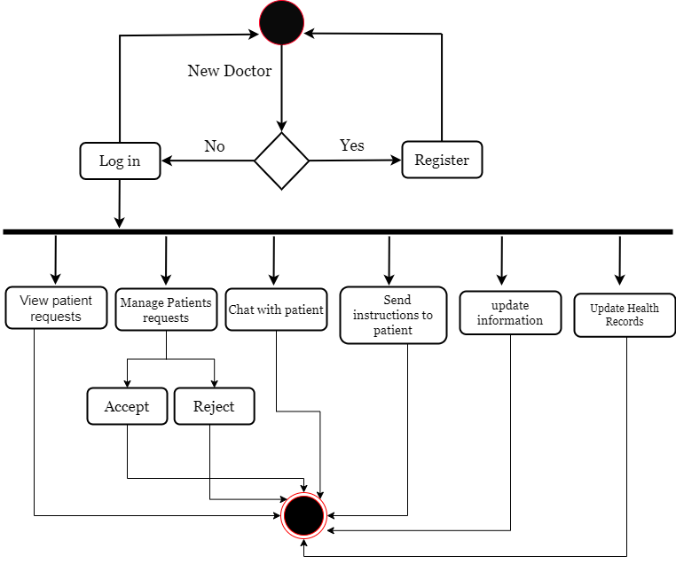
Figure 3. 4: Activity Diagram for Doctor

3.6.3 Activity Diagram for Admin

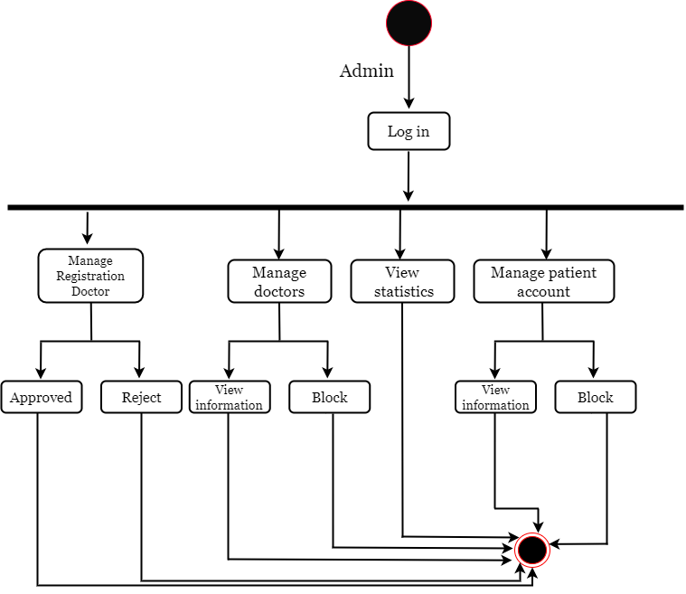

Figure 3. 5: Activity Diagram for Admin

3.7 Sequence Diagram
A sequence diagram, as shown in Figures 3.6 to 3.8, is a type of UML (Unified Modeling Language) diagram used to depict the interactions and sequences of messages between various objects or components within a software system or a specific scenario. It provides a visual representation of the dynamic behavior of the system, illustrating how objects or components collaborate to achieve a particular task or process.

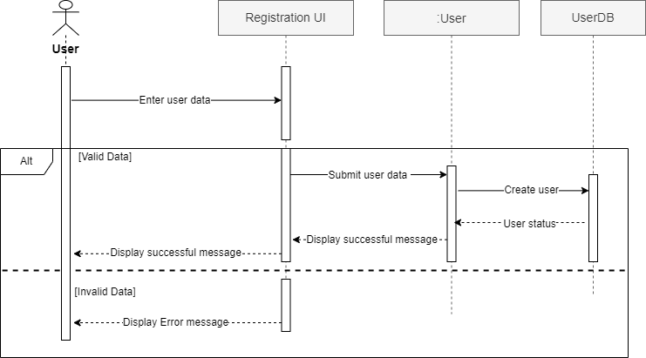
3.7.1 Sequence Diagram for Sign-Up

Figure 3. 6: Sequence Diagram for Sign-Up

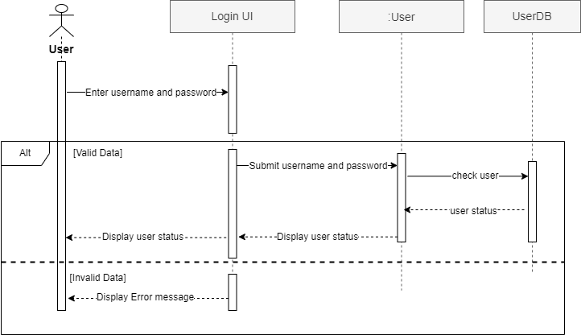
3.7.2 Sequence Diagram for Login

Figure 3. 7: Sequence Diagram for Login

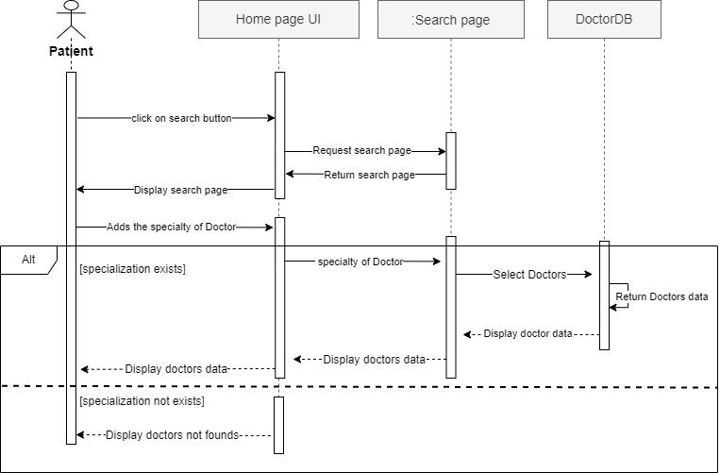
3.7.3 Sequence Diagram for Search for Doctor

Figure 3. 8: Sequence Diagram for Search for Doctor

3.8 Class Diagram
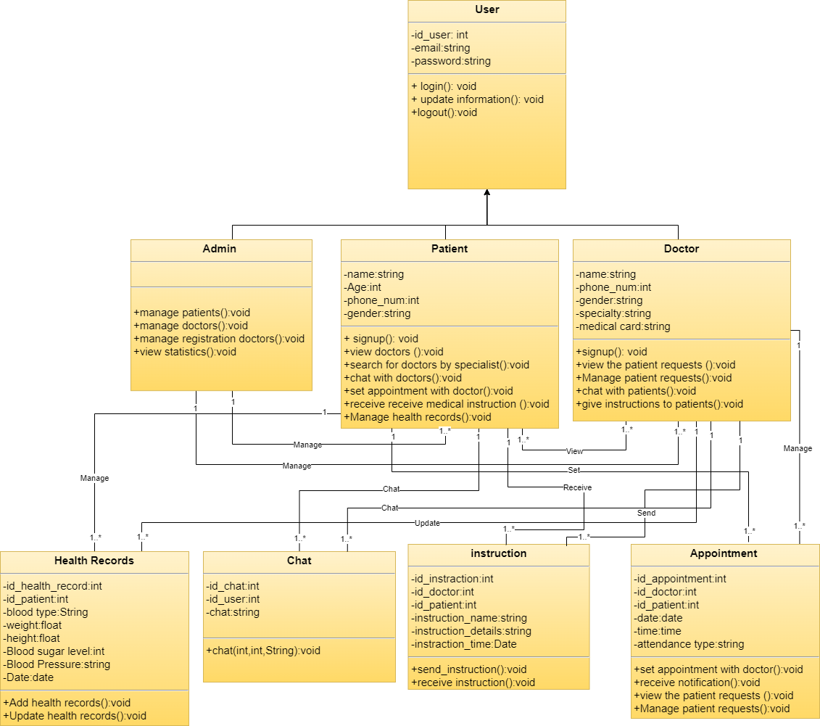
A class diagram, as shown in Figure 3.9, is a type of UML (Unified Modeling Language) diagram used to visually represent the structure and relationships of classes and objects within a software system or application. It provides a detailed overview of the classes, their attributes, methods, and the associations between them.

Figure 3. 9: Class Diagram

3.9 Data Flow Diagram
A data flow diagram is a diagram of the flow of data between various processes in a business, and it is also a graphical technique that visualizes the flow of information that is applied in moving data from input to output. It provides a simple and intuitive way to describe business processes without focusing on the details of computer systems. A data flow diagram can be described as a drawing that shows the movement of data between external entities, processes, and data stores within the system.

3.9.1 Context Diagram
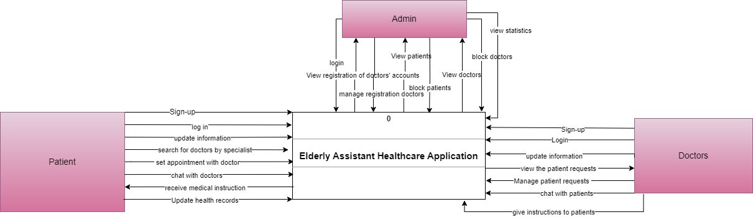
In DFD the environmental level has the highest level of representation. The environmental level shows the relationship between the system and its surrounding external environment (external resources), with the system represented in the diagram as a square and the external sources as rectangles, as well as the data flows (and their direction) that are exchanged between the two. Our proposed system is in Figure 3.10.
Figure 3. 10: Context Diagram

3.10 ERD Diagram
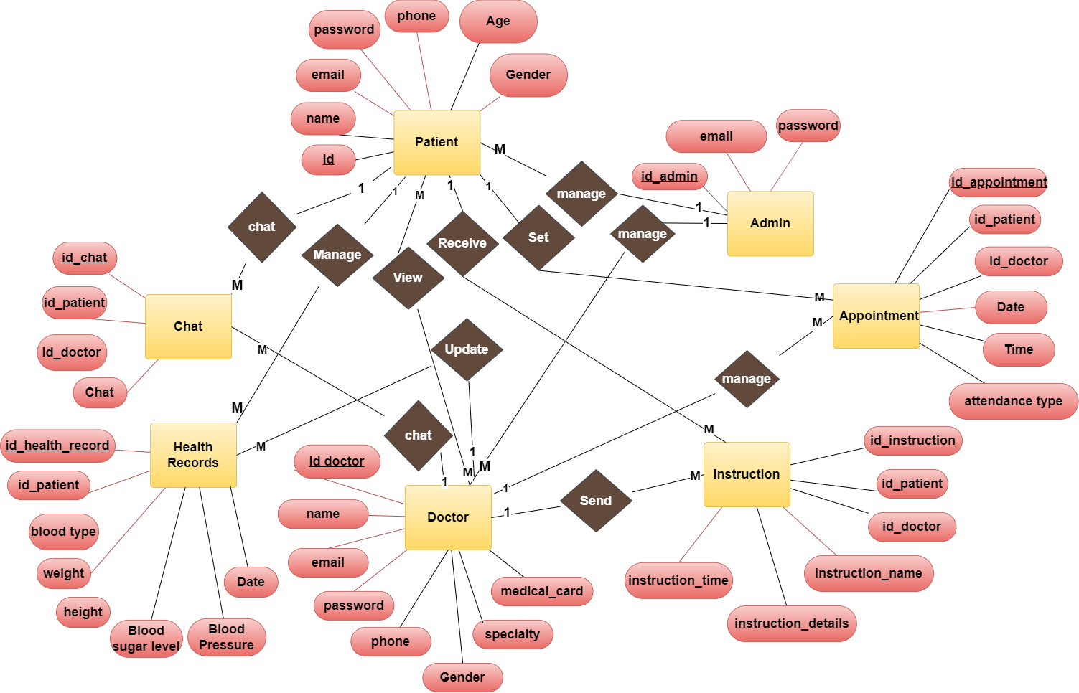
An Entity-Relationship (ER) diagram, as shown in Figure 3.11, is a visual representation used in database design to illustrate the structure of a database, including the entities (objects or concepts), their attributes, and the relationships between them. It provides a clear and concise way to model the data schema of a database system.

Figure 3. 11: ERD Diagram

REFERENCES

- App Store. (2013, June 11). Teladoc Health - Telehealth. https://apps.apple.com/us/app/teladoc-health-telehealth/id656872607?platform=iphone
- MyChart - apps on Google Play. (n.d.). https://play.google.com/store/apps/details?id=epic.mychart.android&hl=en
- HealthTap - Telehealth Doctors - apps on Google Play. (n.d.). https://play.google.com/store/apps/details?id=com.healthtap.userhtexpress&hl=en_US
- Arb, Ghusoon Idan, and Kadhum Al-Majdi. "A freights status management system based on Dart and Flutter programming language." Journal of Physics: Conference Series. Vol. 1530. No. 1. IOP Publishing, 2020.‏
- Hagos, T., & Hagos, T. (2018). Android studio. Learn Android Studio 3: Efficient Android App Development, 5-17.‏
- Dagne, L. (2019). Flutter for cross-platform App and SDK development.‏
- Moroney, L., & Moroney, L. (2017). The firebase realtime database. The Definitive Guide to Firebase: Build Android Apps on Google's Mobile Platform, 51-71.

